Goals
The learning objective of this lab is to become familiar with Osquery and its detection capabilities.

What you will learn
You will learn how to hunt for linux process injection leveraging Osquery.

Recommended tools
- Osquery
- https://github.com/kolide/fleet
NOTE - Before you can begin the lab,
- Execute start.sh script to enroll the endpoint to Kolide Fleet.
cd /root/Desktop/osquery-client/
./start.sh
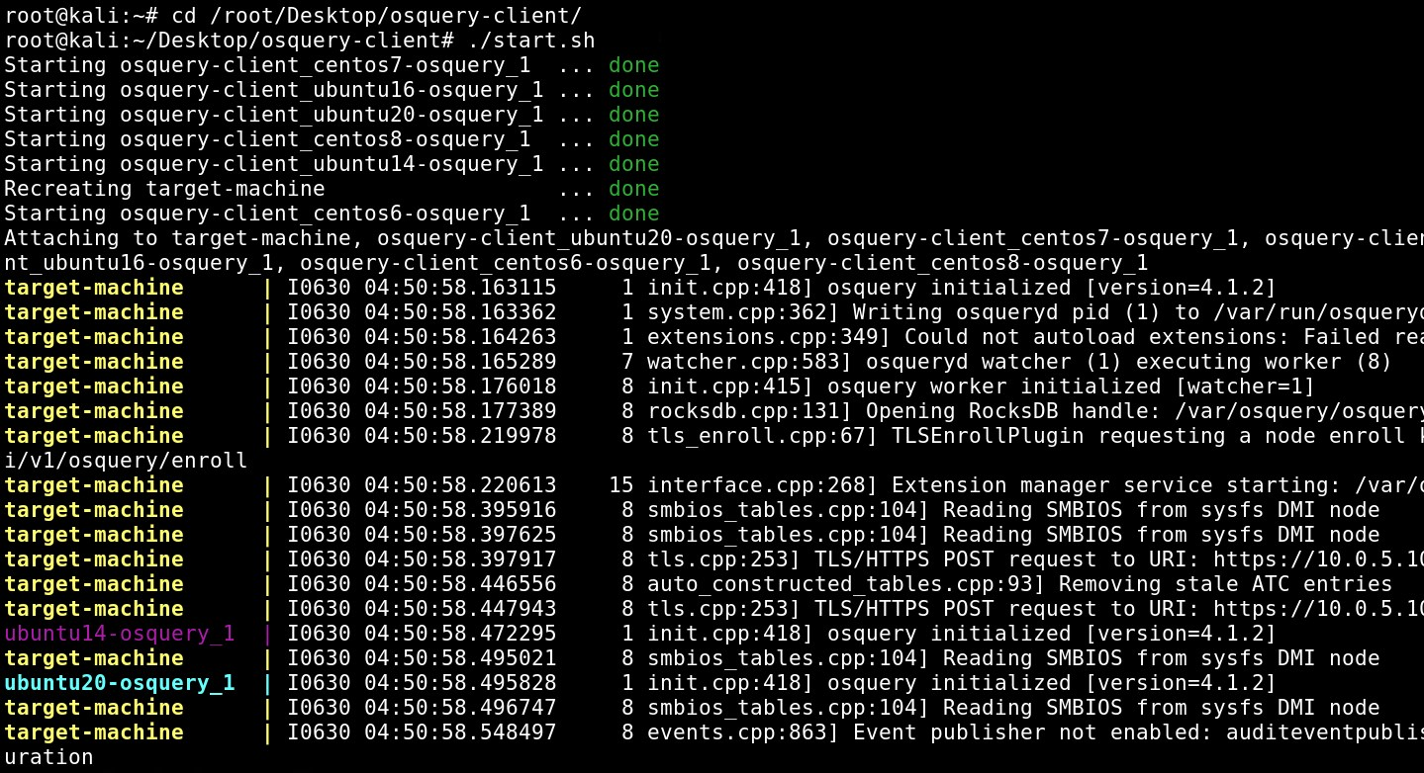
You should now be able to see the endpoint inside Kolide fleet (name: target-machine)
Note: While accessing the Kolide fleet ignore the certificate warnning.
URL https://10.0.5.10:8412/login
Username: admin
Password: P@$$w0rd123321
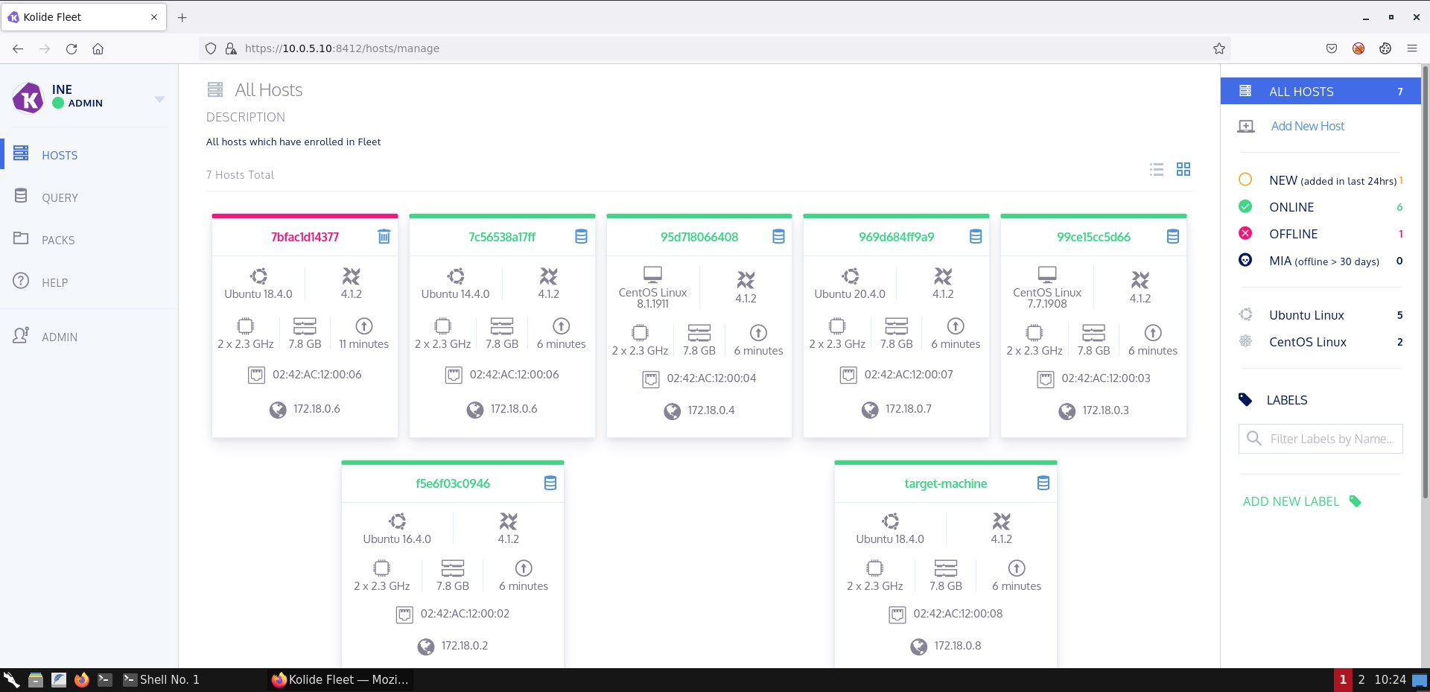

Hunting At Scale With Osquery

LAB 18

Scenario
In this lab you will learn how to hunt for process injection on Linux endpoints with the help of Osquery. You will also be shown how to execute pre-baked Osquery queries through Kolide fleet to hunt for process injection at scale.
If you are unfamiliar with Osquery. Please refer to our Medium post and video training below.
https://medium.com/@d.bougioukas/blue-team-diary-entry-1-leveraging-osquery-for-enhanced-incident-response-threat-hunting-70935538c9c3

Goals
The learning objective of this lab is to become familiar with Osquery and its detection capabilities.

What you will learn
You will learn how to hunt for linux process injection leveraging Osquery.

Recommended tools
- Osquery
- https://github.com/kolide/fleet
NOTE - Before you can begin the lab,
- Execute start.sh script to enroll the endpoint to Kolide Fleet.
cd /root/Desktop/osquery-client/
./start.sh
You should now be able to see the endpoint inside Kolide fleet (name: target-machine)
Note: While accessing the Kolide fleet ignore the certificate warnning.
URL https://10.0.5.10:8412/login
Username: admin
Password: P@$$w0rd123321

Tasks

Task 1. Emulate and hunt for library injection using Osquery
Access the target-machine Ubuntu container and use the sample target and injection tool residing at /root/Tools/linux-inject to emulate library injection against a Linux process.
Then, try to identify artifacts/traces that can be used to hunt for library injection against a Linux process.
Identify the Osquery tables or functionality that contain information regarding the artifacts/traces you came up with.
Do the same with the injection tool that resides at /root/Tools/ReflectiveSOInjection
Hints:
- https://osquery.io/schema/3.3.2#system_controls
- https://osquery.io/schema/3.3.2#process_memory_map

Task 2. Hunt for library injection using at scale using Kolide Fleet
Perform or schedule the Osquery queries you came up with during Task 1 from inside Kolide Fleet. This way you can perform the same query over multiple endpoints at once...

SOLUTIONS
Below, you can find solutions for each task. Remember though, that you can follow your own strategy, which may be different from the one explained in the following lab.

Task 1. Emulate and hunt for library injection using Osquery
First, let's access the container and start our sample-target process.
docker exec -it target-machine bash
cd /root/Tools/linux-inject
./sample-target
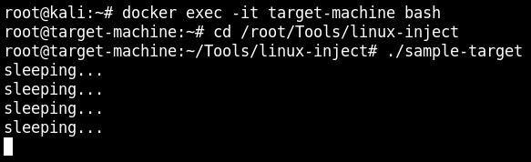
Leave this session running and open a new container session and perform the injection as follows.
docker exec -it target-machine bash
cd /root/Tools/linux-inject
./inject -n sample-target sample-library.so
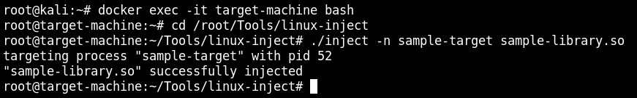
The injection performed successfully.
This is what you will see inside the SSH session where sample-target is running.
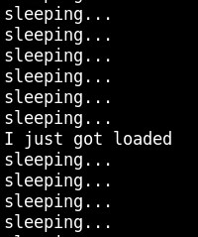
Let's continue with the detection part, as follows.
osqueryi
select * from system_controls WHERE name == 'kernel.yama.ptrace_scope';
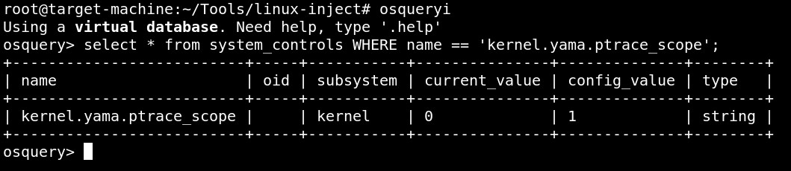Still inside the osquery "shell", execute the below.
SELECT process_memory_map.*, pid as mpid from process_memory_map LEFT JOIN processes USING (pid) WHERE process_memory_map.path LIKE '/%' and process_memory_map.pseudo != 1 AND process_memory_map.path NOT LIKE '/lib/%' AND process_memory_map.path NOT LIKE '/usr/lib%' AND process_memory_map.path != processes.path AND process_memory_map.permissions LIKE '%x%';
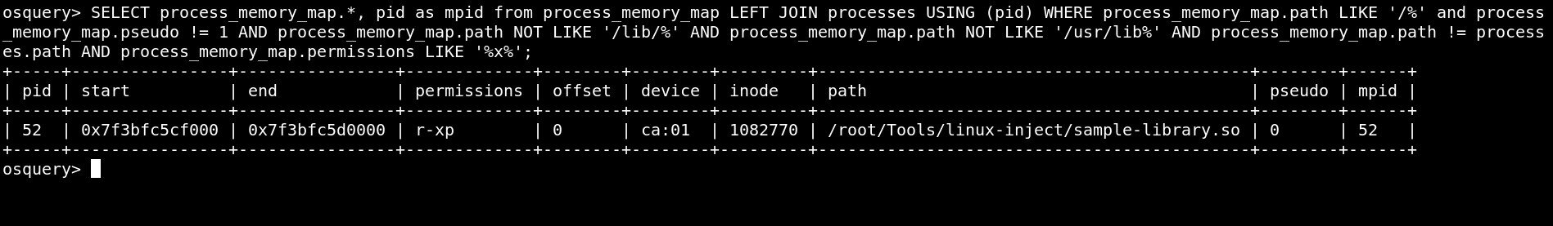The above query looks at the process memory using Osquery's process_memory_map table. We are interested in memory locations that have the execute permission. The original image as well as locations marked as pseudo should be disregarded. We should also remove known paths where libraries are loaded. Now, delete the injected library (you can exit osqueryi by executing .exit).
CTRL + C
ls
rm sample-library.so
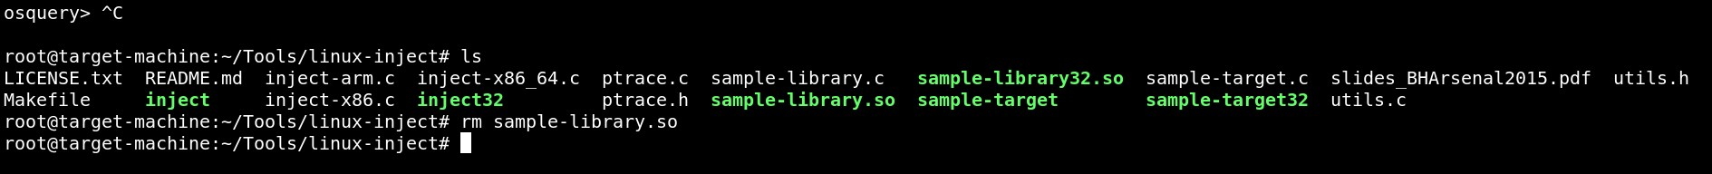Execute osqueryi again and issue the query below.
osqueryi
SELECT process_memory_map.pid, process_memory_map.start, process_memory_map.end, process_memory_map.permissions, process_memory_map.offset, process_memory_map.path from process_memory_map LEFT join file USING (path) where pseudo != 1 AND process_memory_map.path NOT LIKE '/lib/%' AND process_memory_map.path NOT LIKE '/usr/lib%' AND process_memory_map.permissions LIKE '%x%' AND filename IS NULL and process_memory_map.inode !=0 AND process_memory_map.permissions = 'r-xp';
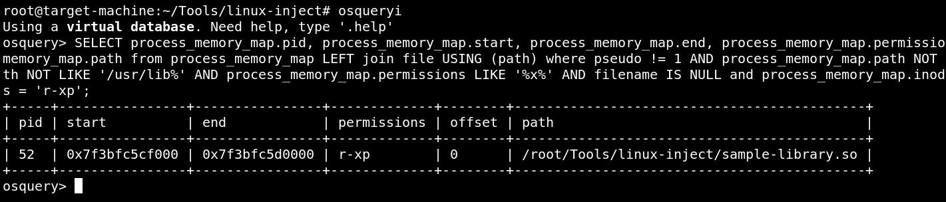The injected library is still visible! Terminate osqueryi. Let's try the other injection tool. Terminate sample-target and start it again inside the other SSH session.
cd /root/Tools/ReflectiveSOInjection/inject/src
ps aux (to identify the PID of sample-target)
./inject -p PID_of_sample_target ../../so/src/ReflectiveLoader.so
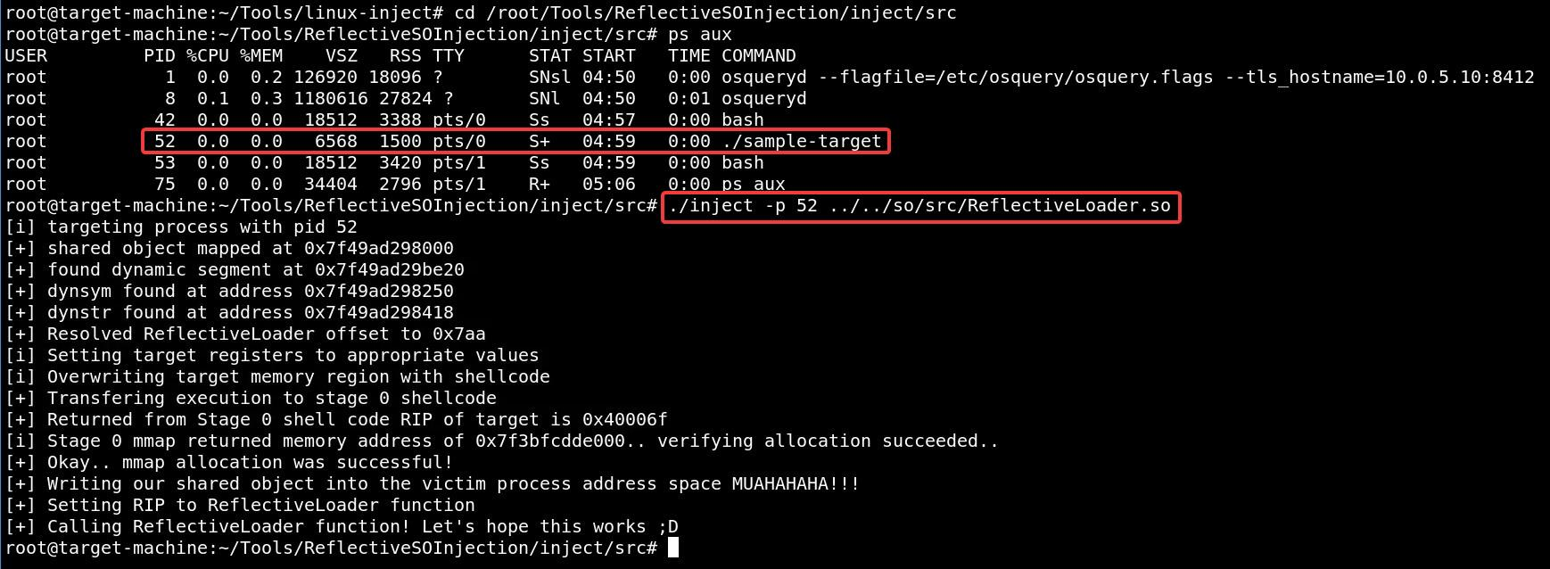Let's detect the library injection, again using osquery.
osqueryi
SELECT processes.name, process_memory_map.*, pid as mpid from process_memory_map join processes USING (pid) WHERE process_memory_map.permissions = 'rwxp' AND process_memory_map.path = '';
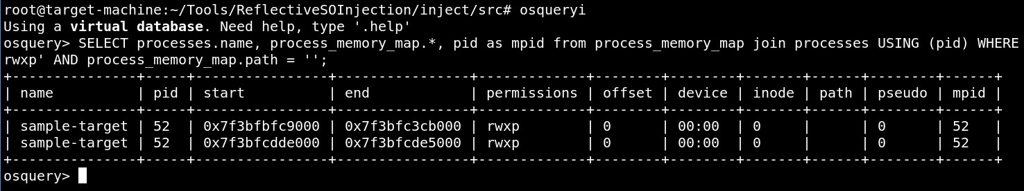The advantage of the second library injection technique is that the injected shared object doesn't have to be on disk. That's why the query above searches for memory regions marked as rwxp having an empty path.

Task 2. Hunt for library injection using at scale using Kolide Fleet
First, log into Kolide Fleet and create a new query, as follows. 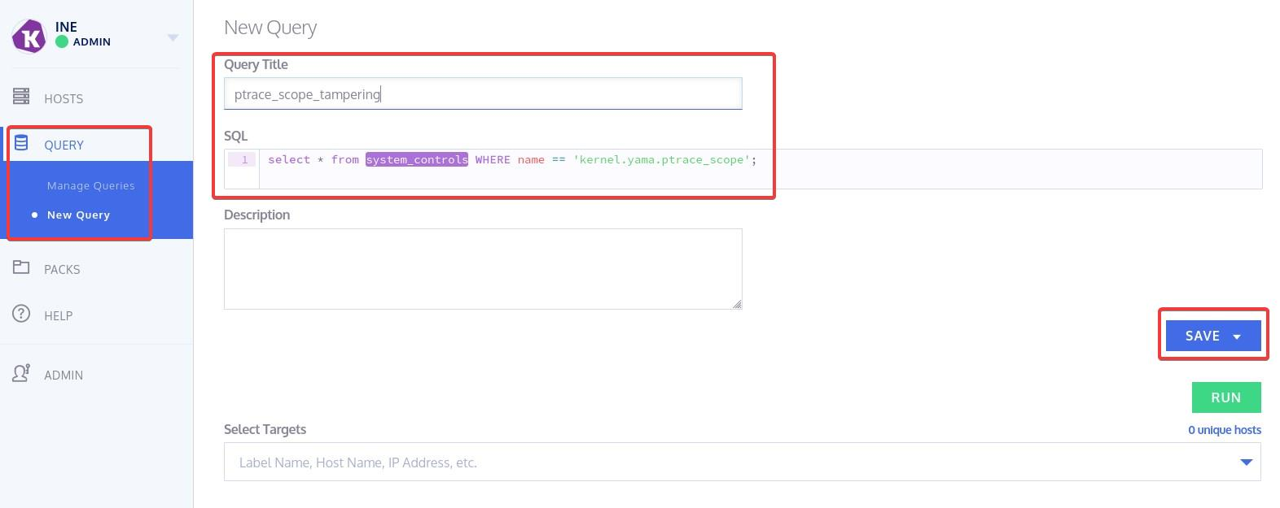Inside SQL, enter the below query (the one we used before to detect the first library injection tool).
select * from system_controls WHERE name == 'kernel.yama.ptrace_scope';
Then, select all Ubuntu hosts, by pressing the + sign next to them and finally click SAVE (as new) 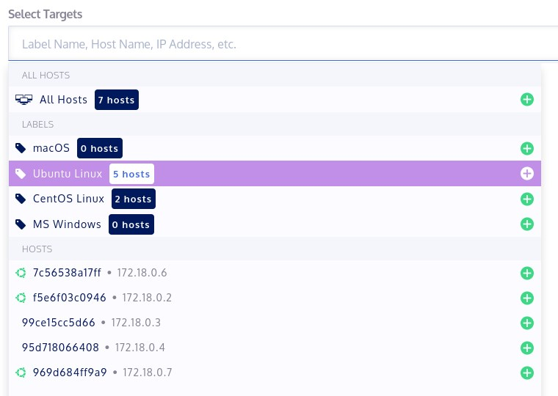This is what you should see if you press the database icon on your left. 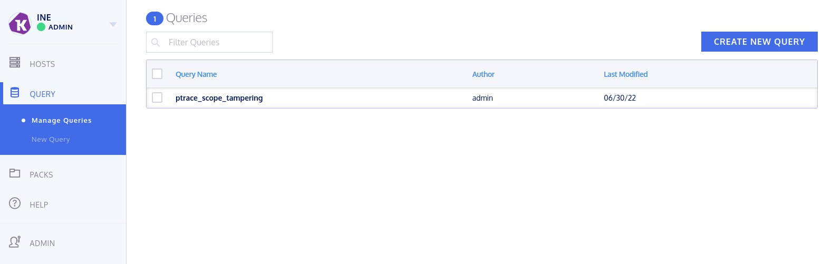Now click the folder icon and then click "create new pack". 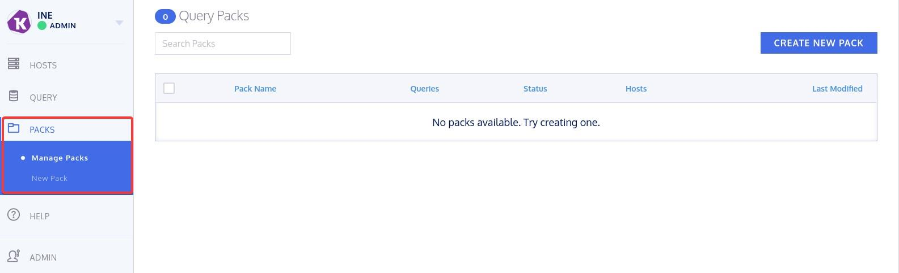Once again add all Ubuntu hosts and click Save. 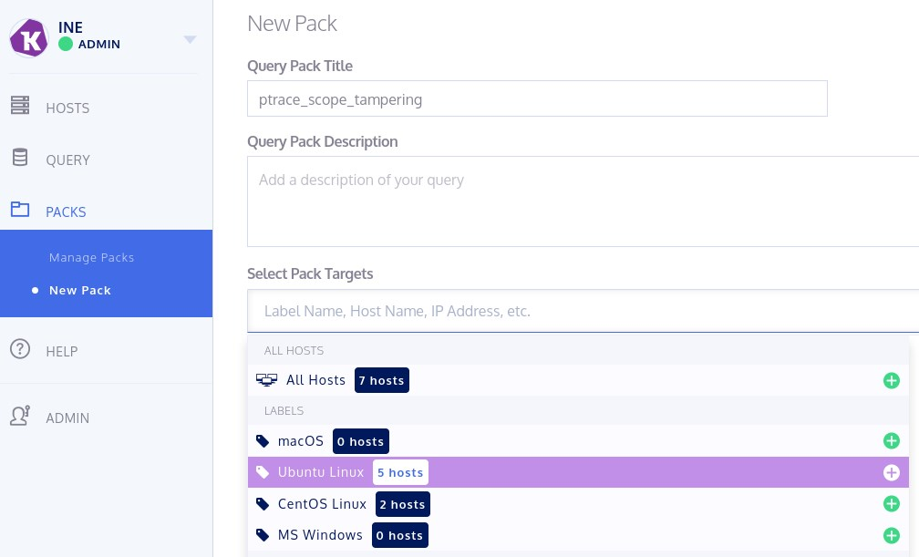This is what you should see when clicking the folder icon. 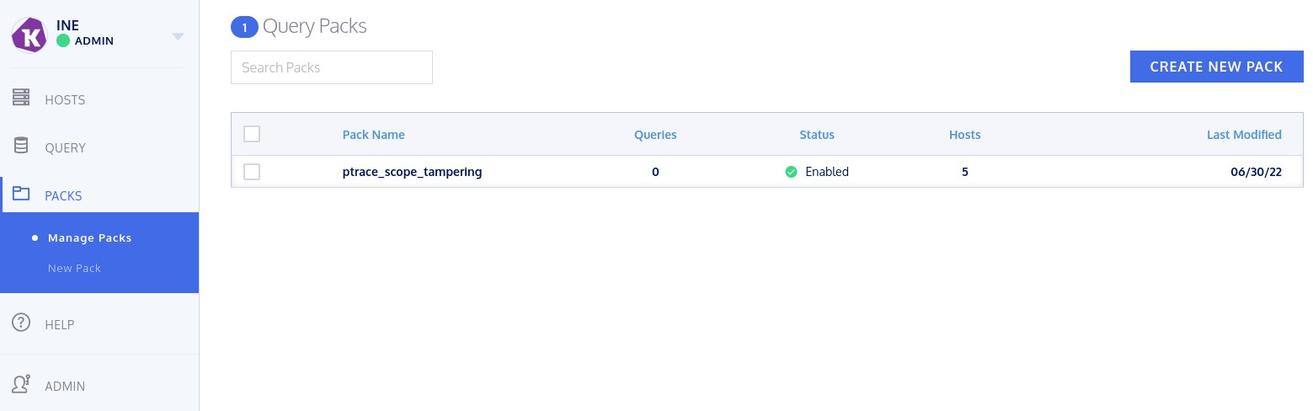Click on the pack you created and then click "Edit Pack" on your right. 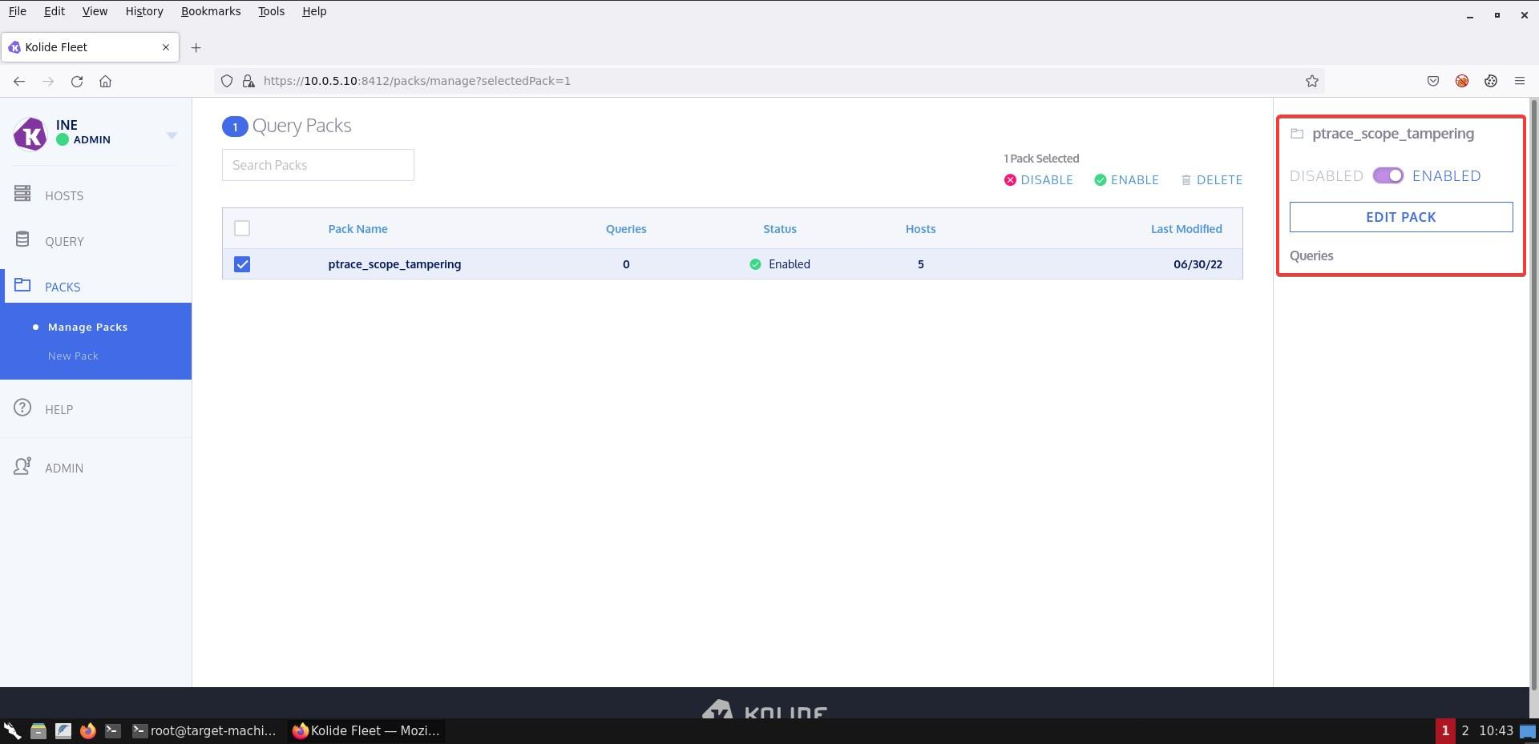Choose the ptrace-related query you created from the menu on your right and configure as follows. 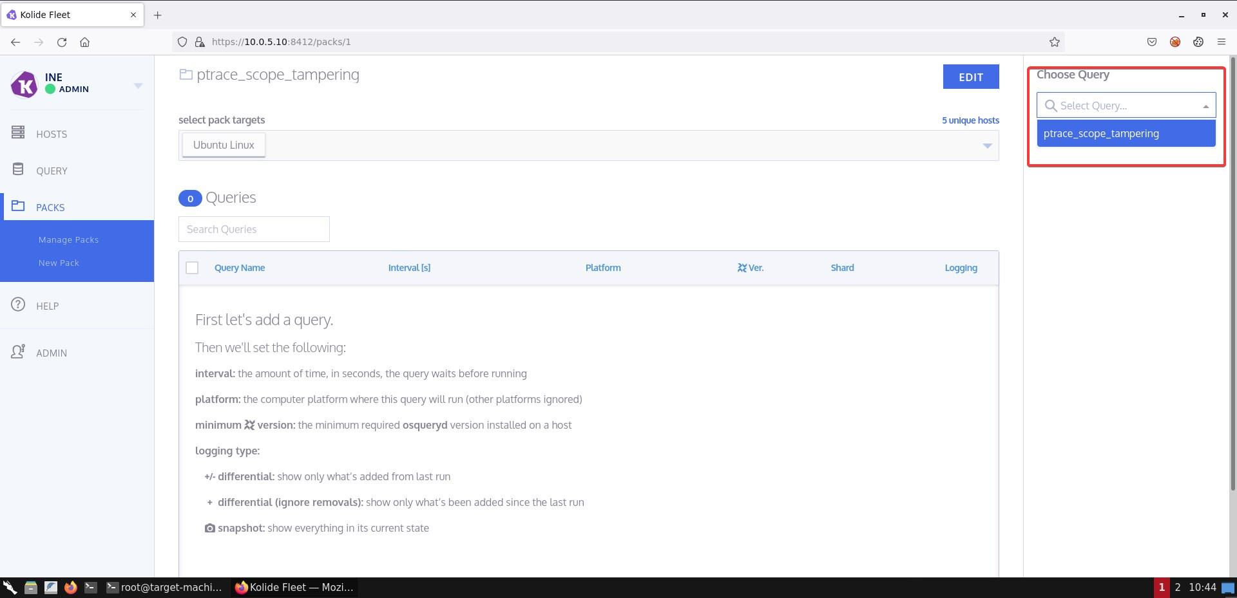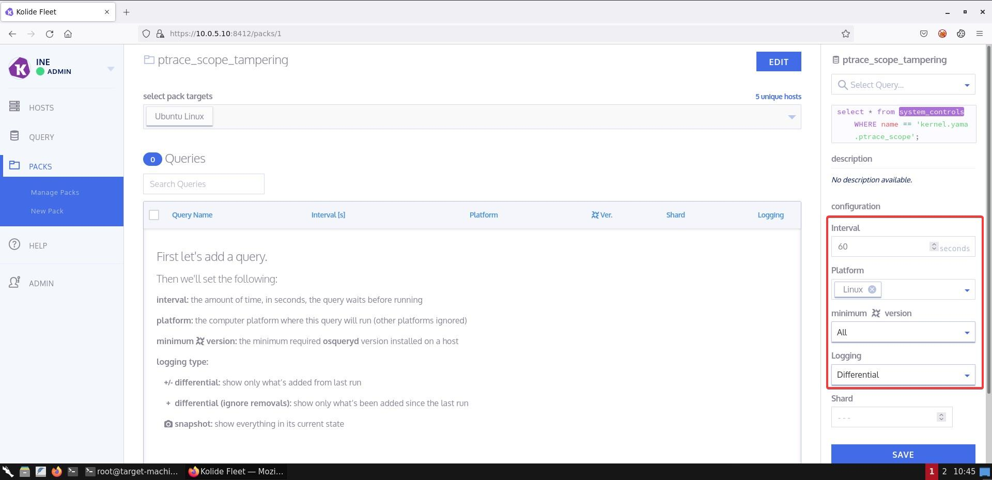Finally, click Save at the bottom. 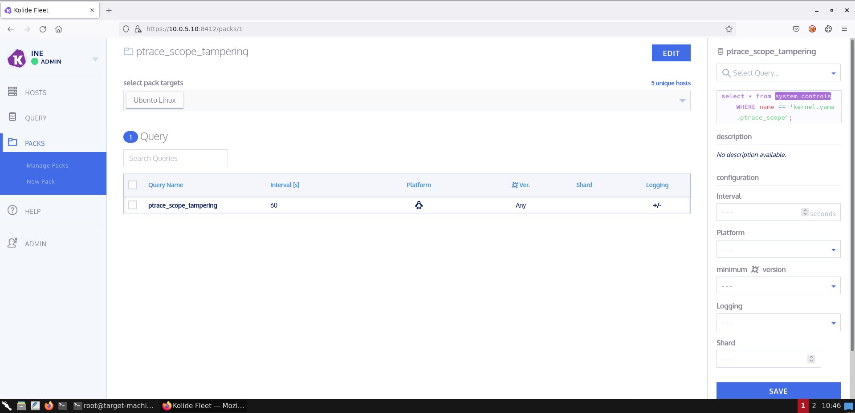Fleet logs are being pushed to an ELK instance at http://10.0.5.10:5601 There you should be able to identify changes to the ptrace scope, at scale. For example, change back the ptrace scope on the osquery_client machine as follows and you should see a new event inside Kibana.
echo 1 | tee /proc/sys/kernel/yama/ptrace_scope
Go to Discover 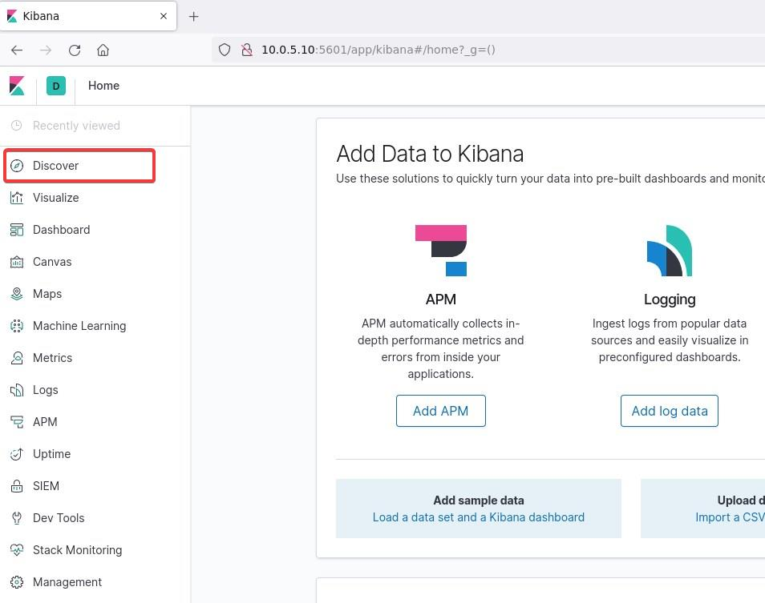Create an index 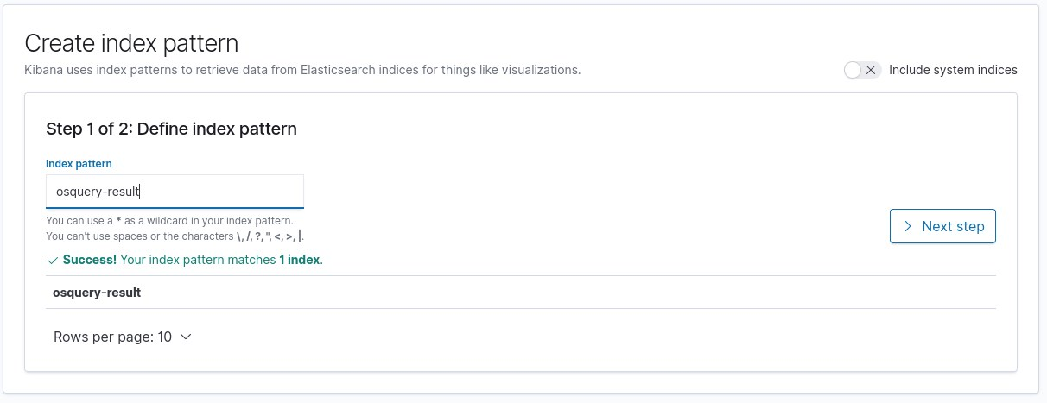In configure settings select @timestamp and Click on create index pattern 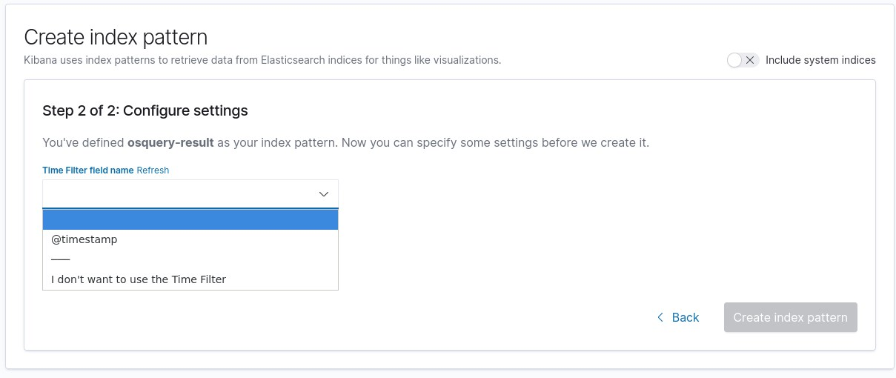Again go to Discover, you should see the new events inside Kibana. 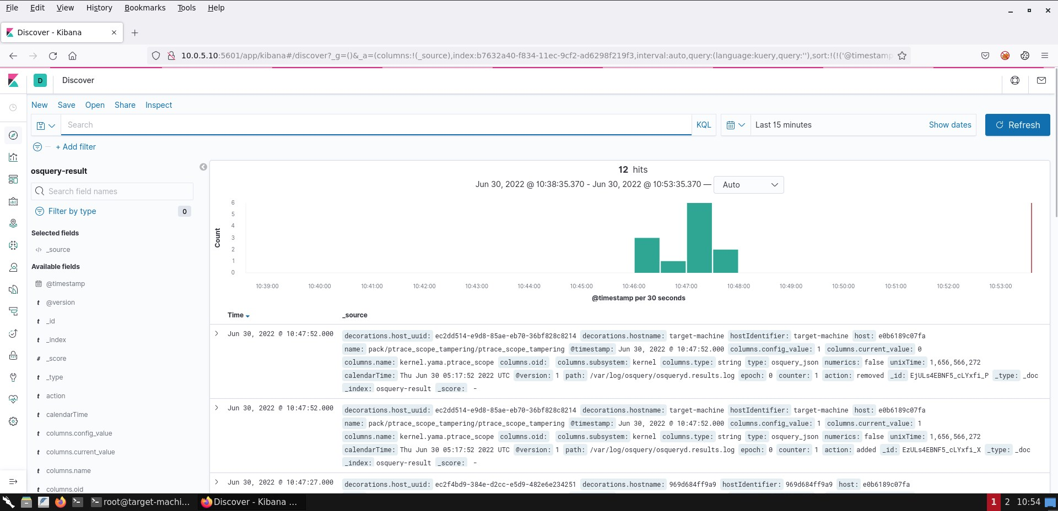

Resources
- https://www.trustedsec.com/blog/linux-hows-my-memory/
- https://cybersecurity.att.com/blogs/labs-research/hunting-for-linux-library-injection-with-osquery

KEY TAKEWAYS
- There are numerous ways for an adversary to achieve their goal. Being familiar with as many as possible attacks can aid hunters in creating better detection rules performing successful hunts.
- Hunting playgrounds are a great source of different attacks, helping hunters in increasing their abilities.

